Geology and Climate of the Galápagos Islands

The Galápagos archipelago (archipelago is a large group of islands) straddles the equator in the Pacific Ocean about 1,000 kilometers (620 miles) off the western coast of Ecuador. There are 17 major islands and an almost equal number of islets. Part of what makes visiting the | 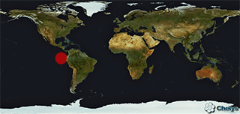
Galápagos so fascinating is that they are in the early phase of their development. A little over four million years ago there was open ocean where the islands now lie.

Seeing every height crowned with its crater, and the boundaries of most of the lava streams still distinct, we are led to believe that within a period, geologically recent, the unbroken ocean was here spread out.
-Charles Darwin, 1845

Submarine volcanic activity slowly built up the chain of islands that Darwin visited in September of 1835. Indeed, it was Darwin who first recognized they were volcanic in origin. He understood the profound implications of this origin for the history of life; for if the islands were volcanic, they must have appeared after the formation of the earth and the organisms living there must have migrated from someplace else. But since these inhabitants are endemic (found nowhere else), Darwin finally concluded that they had evolved in isolation from South American ancestors.

After Darwin's visit and well into the 20th century, the origin of the islands was disputed. Many thought that they had once been part of the mainland or connected to it by a land bridge. Of course, now we know that these islands have a volcanic origin separate from the mainland and were never connected to it.

The Galápagos Islands formed as the tectonic plate on which they sit (the Nazca Plate) slowly moved over a stationary “hot spot” in the Earth’s mantle. Outpourings of magma and lava from the hot spot gradually built the islands up to sea level. Islands farther from the hot spot are older and more eroded, while islands near or on the hot spot are younger and steeper.  The movement of the Nazca plate over the hot spot during the past 4+ million years has been toward the southeast (see map). This means that the easternmost islands such as San Cristóbal and Floreana, formed first and are the oldest, at over 4 million years. The westernmost island, such as Fernandina and Darwin, are the youngest. In fact, | 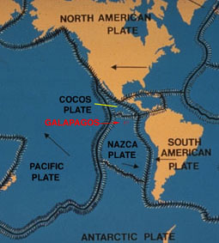
Fernandina dates to less than 7,000 years and is considered to be one of the most active volcanoes in the world. Recently, former Galápagos Islands, now submerged, were discovered between San Cristóbal and the mainland. This discovery may double the age of the islands.

Climate
One of the keys to understanding the Galápagos Islands is the climate. The islands are isolated (by several hundred miles of ocean), so the climate is controlled almost entirely by the ocean currents, which in turn are influenced by the trade winds which push the currents. The Galápagos is a major intersection of several currents, which vary in intensity during the year as their driving trade winds blow and then weaken in a cycle that gives two distinct seasons to the islands.

A hot, rainy period prevails from January to May; a cooler, drier period dominates for the rest of the year (in other words, January and May are transition months). The temperature of water masses off the coast of South America is a key influence on the Galápagos climate. Gradients of temperature and moisture on the islands greatly affect the types of vegetation. At lower and drier elevations, the dominant vegetation is mostly deciduous forest. In the cloud belt that forms at higher elevations, moist forest dominates. At the highest elevations, above the cloud belt, a dry, grassy habitat is common.

Considering that these islands are placed directly under the equator, the climate is far from being excessively hot; this seems chiefly caused by the singularly low temperature of the surrounding water, brought here by the great southern Polar current. Excepting during one short season, very little rain falls, and even then it is irregular; but the clouds generally hang low. Hence, whilst the lower parts of the islands are very sterile, the upper parts, at a height of a thousand feet and upwards, possess a damp climate and a tolerable luxuriant vegetation. This is especially the case on the windward sides of the islands, which first receive and condense the moisture from the atmosphere…
-Charles Darwin, 1845

