Bioluminescence

Photosynthesis transforms light energy into chemical energy. In bioluminescence, the reverse can happen - chemical energy is converted into light energy. Bioluminescence is common in the oceans, where hordes of glowing microscopic organisms called dinoflagellates can lend an eerie bluish cast to fishes, dolphins or even ships as they move through the water. From the back of the boat, you’ll see bioluminescent squid by the hundreds.

Bioluminescence is not the same as "fluorescence". In fluorescence, energy from a source of UV light is absorbed and reëmitted as another photon. In bioluminescence the excitation energy is supplied by a chemical reaction rather than from a source of light. The light is produced through a chemical reaction involving luciferin (the substrate), luciferase (the enzyme), ATP (energy), and oxygen (O₂).

In a cell, luciferin reacts with ATP. This activates the luciferin, allowing oxygen to bond to one of its carbon atoms and boosting an electron into a higher orbit. Luciferin then releases the oxygen and carbon as carbon dioxide (CO₂). As the electron drops back to its customary orbit, the spent energy is released as a tiny flash of light. This process, which uses ATP and oxygen to produce light and carbon dioxide, is the exact opposite of photosynthesis.

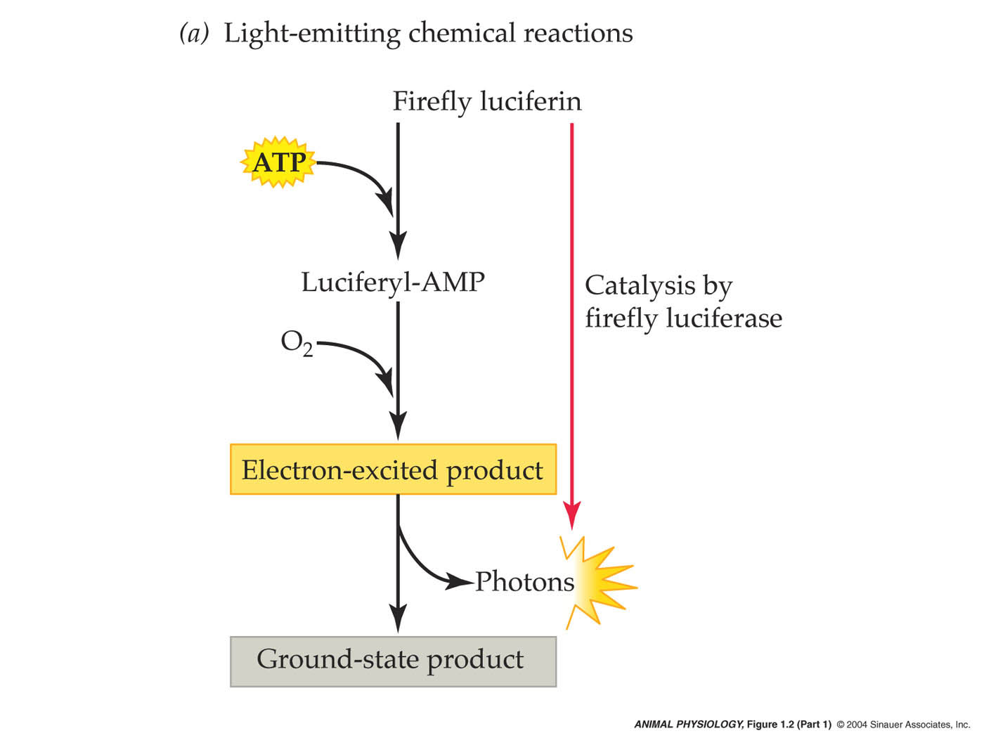

Chemical companies sell luciferin and luciferase, which researchers use to detect ATP. When ATP appears in a sample of any substance, it indicates contamination by an organism. For example, the manufactures of Coca-Cola use firefly luciferin and luciferase to detect bacteria in syrups used to produce the beverages. Contaminated syrups glow in the presence of luciferin and luciferase because the ATP in the bacteria sets the bioluminescence reaction into motion. Firefly luciferin and luciferase were also aboard the Viking spacecraft sent to Mars. Scientists sent the compounds to detect possible life (a method that would only work if Martians use ATP).

PS You will find luciferin and luciferase aboard the boat in the oddest place….. try flushing your toilet at night (without turning on any lights).

