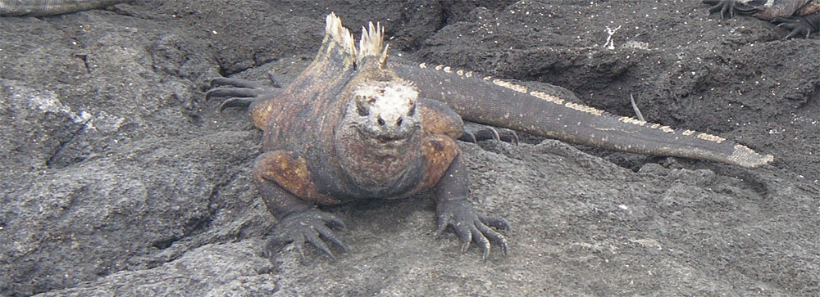

Marine Iguanas

Your introduction to the reptilian wildlife of the Galápagos will probably be the marine iguana. Your first encounter may be somewhat shocking—it takes a while to get past their Godzilla-like appearance. It’s easy to forget that these reptiles are vegetarians when you see the claws and the crest of spines running down the back (of the male). But, of course, they are harmless and after a few days in the Galápagos, they’ll start looking kind of cute.

In 1798, Captain James Collnett wrote:  "The iguanas are small, and of a sooty black, which, if possible, heightens their native ugliness. Indeed, so disgusting is their appearance that no one on board could be prevailed on to take them as food." | 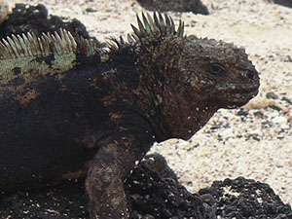

Even Darwin himself was repulsed by them, noting that “The rocks of the coast abounded with great black lizards…. a hideous looking creature, of a dirty black color, stupid, and sluggish in its movements”.

He wrote in his diary:
"The black lava rocks on the beach are frequented by large (2-3 ft) most disgusting clumsy Lizards. They are as black as the porous rocks over which they crawl & seek their prey from the Sea. Somebody calls them 'imps of darkness'. They assuredly well become the land they inhabit."

Marine iguanas are widely distributed on lava rock shores throughout the islands. The different populations vary in size and color, they are all considered to be of a single species, Amblyrhynchus cristatus. The smallest are found on Genovesa, the greatest number are on Fernandina (you’ll see them basking in large piles), and the most colorful are on Espanola. These iguanas have blotches of coppery red color (see below).
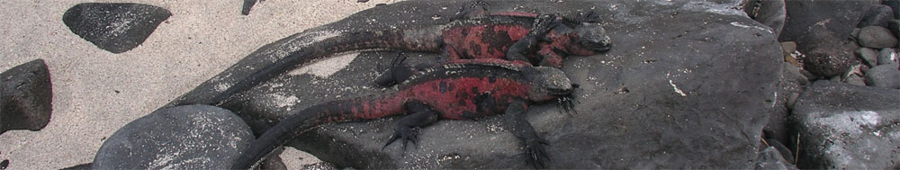

For ectothermic animals like marine iguanas, temperature regulation is a problem due to their daily excursions into the cold Galápagos water. Like other diving animals, marine iguanas can shunt blood away from the surface to conserve heat, and they can drastically slow their metabolism. Typically, the divers are the large males (to depths of 35 feet), while the rest of the colony feeds in the intertidal zone. Their diet consists almost entirely of seaweed. (In the Voyage of the Beagle, Darwin described how one of the sailors attempted to kill a marine iguana. Why did his technique fail?)

When they return from the sea, it takes them most of the day to warm up. They spend much of their time sunbathing on the black rocks in an elevated position, angling their bodies toward the sun. You’ll see whole colonies “catching rays” in the same frozen position. At night they often huddle together to conserve heat. Overheating can also be a problem and the iguanas have a variety of simple behaviors to prevent this. What behavioral responses would you expect to see marine iguanas use to cool their bodies?

In the "Voyage of the Beagle," Darwin noted:

“When in the water this lizard swims with perfect ease and quickness, by a serpentine movement of its body and flattened tail -- the legs being motionless and closely collapsed on its sides. Their limbs and strong claws are admirably adapted for crawling over the rugged and fissured masses of lava which everywhere form the coast.”

The flattened tail, mentioned in the excerpt above, increases their swimming ability and the long, sharp claws (longer and sharper than land iguanas) allow them to cling to rocks along the shore and resist being pulled away by the strong wave action in the intertidal zone. The genus name of the marine iguana, Amblyrhynchus, (amblys = short, rhynchos = nose) is derived from the characteristically blunt snout, which enables them to efficiently scrape vegetation off of the rocks with their razor-sharp teeth.

The evolution of the marine iguana and its relationship with the land iguana is not well understood. It has always been assumed that the marine iguana evolved from the land iguana, and some data supports that assumption. Other evidence suggests that the land and marine iguanas are no more closely related to each other than to any of the other iguana genera. Molecular studies of the marine iguana suggest that these iguanas diverged from other iguanas around 8 million years ago. The oldest Galápagos island, however, is only around 4 million years old. The marine iguana may have originally evolved on the mainland and colonized the Galápagos in their present form. An alternative theory is that they evolved on the former, now submerged, Galápagos Islands.

Darwin wrote:
“It is…. most remarkable, because it is the only existing lizard which lives on marine vegetable productions…. We must admit that there is no other quarter of the world where the Order replaces the herbivorous mammalian in so extraordinary a manner.”

