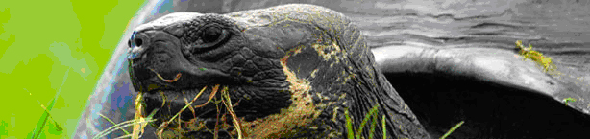

The Giant Tortoises of the Galápagos

No animal is more synonymous with the Galápagos Islands than the giant tortoise. The shape of its shell reminded the early Spanish explorers of a type of riding saddle called a galápago, so they applied the name Galápagos to both the tortoises and their island home. By calling the islands the Galápagos, we are literally calling them “the Islands of the Giant Tortoise”. It is the face of the giant tortoise that will be stamped on your passport!

It was the giant tortoise that tipped Darwin off to the incredible diversity of the Galápagos fauna and flora. In the "Voyage of the Beagle," he noted:
“I have not as yet noticed by far the most remarkable feature in the natural history of this archipelago; it is that the different islands to a considerable extent are inhabited by a different set of beings. My attention was first called to this fact by the Vice-Governor, Mr. Lawson, declaring that the tortoises differed from the different islands, and that he could with certainty tell from which island any one was brought. I did not for some time pay sufficient attention to this statement, and I had already mingled together the collections from two of the islands. I never dreamed that islands, about fifty or sixty miles apart, and most of them in sight of each other, formed of precisely the same rocks, placed under a quite similar climate, rising to a nearly equal height, would have been differently tenanted; but we shall soon see that this is the case. It is the fate of most voyagers, no sooner to discover what is most interesting in any locality, than they are hurried from it; but I ought, perhaps, to be thankful that I obtained sufficient materials to establish this most remarkable fact in the distribution of organic beings.”
Eleven closely related races, or subspecies, of giant tortoises inhabit the Galápagos today (see table below). Of these, six live on just a single island each; the other five inhabit Isabela (one for each major volcanic region). Four other subspecies that are now extinct are also known. Sadly, the next one to go extinct may be the subspecies from Pinta. It is represented today by a lone surviving individual, a male in his seventies named Lonesome George (there is more information about George on the homepage).

The subspecies are very similar genetically, and they are all considered to be members of the single species Geochelone elephantopus. They are likely modified descendants of an ancestral tortoise species (perhaps a single pregnant female or a small group of breeding individuals) that reached the islands more than a million years ago. These large reptiles are not swimmers, so how do you think the ancestor might have made it to the islands?

The 15 Subspecies of Galápagos Giant Tortoises

Genus | Species | Subspecies | Island
Geochelone | elephantopus | elephantopus (extinct) | Floreana
‘’ | ‘’ | (not described, extinct) | Santa Fe
‘’ | ‘’ | phantastica (extinct) | Fernandina
‘’ | ‘’ | wallacei (extinct) | Rábida
‘’ | ‘’ | hoodensis | Espaňola
‘’ | ‘’ | abingdoni | Pinta
‘’ | ‘’ | ephippium | Pinzón
‘’ | ‘’ | chatamensis | San Cristobal
‘’ | ‘’ | darwini | Santiago
‘’ | ‘’ | vicina | Isabela
‘’ | ‘’ | guntheri | Isabela
‘’ | ‘’ | vandenburghi | Isabela
‘’ | ‘’ | microphyes | Isabela
‘’ | ‘’ | becki | Isabela
‘’ | ‘’ | porteri | Santa Cruz

Biologists think today’s tortoise subspecies are still capable of interbreeding to some extent in the wild; however, captive breeding in zoo populations between different subspecies show decreased fertility. The reasons for this are unclear but could be genetic. If this is the case, the subspecies are very likely in the process of becoming fully separate species. The biological definition of the term species requires that all members of a species be groups of interbreeding individuals that produce fertile offspring and are reproductively isolated from other such groups. A basic prediction of evolutionary theory is that geographically isolated subspecies will gradually come to differ across time, until they eventually become distinct reproductively isolated species.

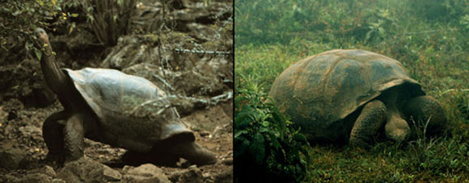

The various Galápagos tortoises can be divided into two general morphotypes: domed and saddle-backed. In the domed tortoises, the front edge of the shell is low and just above the neck. In saddle-backed tortoises, the front edge arches high above the neck. The differences in shell shape are related to the types of food the tortoises eat. Domed tortoises live in moist highlands and eat grasses and low-lying shrubs. Saddle-backed varieties live in arid regions and feed on plants that are mostly above their heads, such as the treelike Opuntia (prickly pear) cactus. How do you think these different shell types adapt the tortoises to life in their respective habitats?

There is a very interesting relationship between tortoises and the various Opuntia species that inhabit the various islands. On those islands where there has never been any evidence of resident tortoise populations (Genovesa), the resident Opuntia species (O.helleri) tends to spread low over the ground and has soft, flexible spines (see picture of the swallowtail gull standing on the Opuntia on the homepage), whereas on islands such as Santa Cruz that have established tortoise populations, the resident species tends to grow as trees (see picture of O. echios to right). As young plants, the trunks are thickly covered with long, sharp spines which will become a tough, tree-like bark in older plants. These plants are inaccessible to the tortoise until the seed-filled fruits fall to the ground. The seeds pass unharmed through the tortoise's gut and are dropped as the tortoise wanders from place to place. | 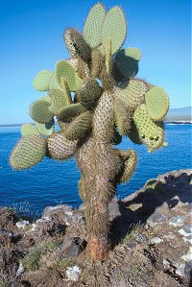
Tortoises are also found in South America, Asia, and Africa but they are mostly small to medium-sized varieties. Giant tortoises are found only on the Galápagos Islands and on Aldabara Island (E. gigantea) in the Indian Ocean. The giant tortoise is the official symbol of the Charles Darwin Research Station and of the Galápagos National Park Service. Because of captive breeding and release efforts by the research station, most of the tortoise varieties are stable today; however, there is ongoing poaching by local residents and there are occasional threats by fishermen. So Lonesome George takes on special significance as a symbol of the vulnerability of Galápagos animals and plants, and as a reminder of the need for continued conservation efforts.

