SYLLABUS
Spring 2015

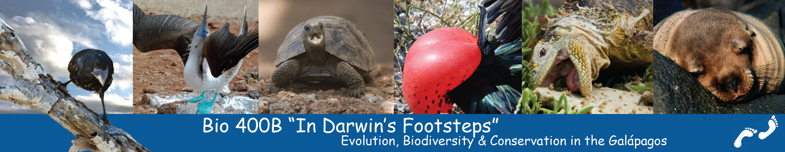

Instructors:
Cynthia Church Harry Jimenez
churchcy@msudenver.edu harryjjjl@yahoo.com
office (303) 556-8467
cell (303) 868-7222

Credit hours: 3

Pre-departure classes: 5:00-8:00 PM Sci2085
Date | Topic
Jan 30 | Course expectations  Geology of the Galápagos (Uwe Kackstaetter)  Dinner at Wazee Supper Club after class (optional)
Feb 13 | Darwin’s Visit to the Galápagos (Cindy Church)  Ecuadorian Pot Luck (optional)
Mar 6 | Organic Evolution (Hsiu-Ping Liu)  What Darwin Never Saw  Student Talks
April 10 | Snorkeling and equipment (Chris Weaver)  Birds of the Galápagos (Cindy Church)  Student Talks
April 24 | Exam  Logistics
TBA | Snorkeling practice (optional)

Prerequisites/Corequisites: BIO 1081 & 1091 or discretion of instructor

Reading Materials:
Textbooks (required)
Carroll, Sean B. (2009) Into the Jungle. Pearson Benjamin Cummings, San Francisco.
Constant, Pierre (2007) The Galápagos Islands: A Natural History Guide (seventh edition). Odyssey Press, New York.

Supplemental Reading (optional)
Darwin, Charles (1839) Voyage of the Beagle (various editions available, including Penguin Books, 1989 and online)

Fitter, Julian, Fitter, Daniel and Hosking, David (2007) Wildlife of Galápagos. Harpercollins, London. (a photographic field guide)

Kritcher, John (2002) Galápagos Islands. Smithsonian Institution Press. Washington, DC. (a more thorough analysis of the islands’ natural history)

Stewart, Paul D. (2006) Galápagos: The Islands that Changed the World. Yale University Press. (published to accompany the TV series Galápagos, first broadcast on BBC in 2006)

Weiner, J. (1994) The Beak of the Finch: A Story of Evolution in Our Time. (Vintage reprint edition,1995) (describes how the Grant’s work on the finches of Daphne Major help us understand mechanisms in evolution)
Course Evaluation:
1. Class attendance and participation pre-departure (10%)
2. Pre-departure class assignments (10%)
3. Presentation (10)%
3. Exam (10%)
4. Maintenance of a detailed field journal and trip log (40%)
5. Field participation (20%)
Trip Cost: See Budget under “Trip Details"
Course Content:

I. Theory of Evolution/Natural Selection
A. Historical Context
1. Pre-Darwinian thinking
2. Darwin’s visit to the Galápagos
a. Darwin’s direct observations
b. Darwin’s on-site experiments
B. The Synthesis of Darwin’s Theory
1. Influence of Darwin’s Contemporaries
a. Malthus
b. Wallace
2. Darwin’s period of reflection
3. Publication of The Origin of the Species
C. In Darwin’s Aftermath—how time has treated Darwin’s work
II. Research in the Galápagos
- Peter and Rosemary Grant (Daphne Major)
- Darwin Research Station (Santa Cruz)
III. Biodiversity of the Galápagos
A. Overview of Island Isolation and Biodiversity
B. Geologic Formation of the Archipelago
1. Overview of plate tectonics
C. Overview of Oceanic Currents
1. Role of currents in biogeography
D. Other Mechanisms of Biogeography
1. Air currents/seeds
2. Flight
E. Major Plant and Animal Groups in the Galápagos Islands
F. Mechanisms of Evolution in the Galápagos
1. Founder effect
2. Adaptive radiation
3. Natural selection
IV. Conservation in the Galápagos
A. Unique nature of the Galápagos
B. Human impacts
1. Extraction of natural resources
2. Tourism
3. Human role in preservation/conservation
4. Formation of the Galápagos National Park
C. Charles Darwin Research Station Visit
Interesting websites:
http://www.literature.org/authors/darwin-charles/ (Charles Darwin’s literary works)
http://www.ucmp.berkeley.edu/history/evotheory.html
http://www.pbs.org/wgbh/evolution/
http://www.darwinfoundation.org
http://www.gct.org
Refunds:
Because of the nature of this charter and the accompanying discounts, the trip fee is non-refundable. Please take special note of the following:

Should you buy travel insurance?
The following advice was in USA Weekend, Feb. 29, 2004:
“… Yes, given our tumultuous political time and trip operators’ stricter cancellation policies. In general, travel insurance covers you for two things: trip interruption or cancellation (due only to circumstances detailed in the policy, so read the fine print) and emergency medical evacuation.
“… http://www.InsureMyTrip.com (is) a site that lets you compare quotes from various insurers.
“It’s important to buy a policy within a week or two of making the first trip payment to get the fullest coverage.”

