Sexual Life Cycles
Sexual reproduction results in greater variation than does asexual reproduction: two parents give rise to offspring that have unique combinations of genes inherited from the two parents. In contrast to a clone, offspring of sexual reproduction vary genetically from their siblings (except in the case of identical twins) and both parents. Genetic variation is an important consequence of sexual reproduction. What generates this genetic variation? We will answer that question as we track the behavior of chromosomes through the sexual life cycle.
In each generation, the doubling of chromosome number that results from fertilization is offset by the halving of chromosome number that results from meiosis. Although the alternation of meiosis and fertilization is common to all organisms that reproduce sexually, the timing of these two events in the life cycle varies, depending on the species. These variations can be grouped into three main types of sexual life cycles:
Animals
The life cycle of a cat (illustrated below) is an example of one type, characteristic of most animals. Gametes are the only haploid cell, all others are diploid. Gametes are produced by meiosis, which undergo no further cell division prior to fertilization. The diploid zygote divides by mitosis, producing a multicellular organism that is diploid.
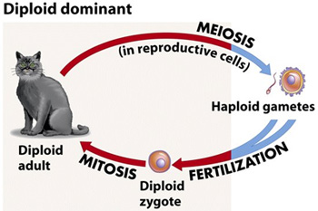
Most fungi and some algae
The life cycle of the green alga shown below illustrates this pattern. In these organisms, the diploid stage consists of a single-celled structure can resist heat and drying. This cell then undergoes meiosis. The haploid cells that result divide by mitosis to give rise to a haploid multicellular adult organism. Subsequently, the haploid organism produces gametes by mitosis, rather than by meiosis. The zygote is the only diploid cell in this life cycle; all other cells are haploid. (Note: Either haploid or diploid cells can divide by mitosis, depending on the type of life cycle; however, only diploid cells can undergo meiosis.)
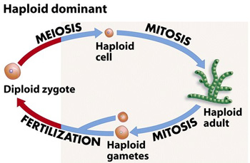

Plants
Plants have a more complicated life cycle that includes multicellular diploid and haploid stages (depending on the species, one of these two stages is larger and longer lived than the other). These stages are called generations, and because they alternate within a life cycle, sexually reproducing plants are said to undergo alternation of generations. The diploid generation produces haploid spores through meiosis. Unlike a gamete, a spore gives rise to a multicellular haploid individual without fusing with another cell. The multicellular haploid generation produces haploid gametes--egg and sperm--which fuse to form a diploid zygote. The zygote divides mitotically and grows into the multicellular diploid individual.
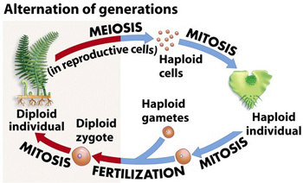
Though the three types of sexual life cycles differ in the timing of meiosis and fertilization, they share a fundamental result: Each cycle of chromosome halving and doubling contributes to genetic variation among offspring.

