Parasitology

COURSE LEARNING OBJECTIVES
- Evaluate parasitism's place in nature and the role of parasites in human history.
- Diagram the basic life cycle patterns, host specificity, micro-habitat selection, and modes of transmission found in the major groups of parasites.
- Analyze various anatomical and physiological adaptations of parasitism.
- Apply the principles of immunology to the parasite-host relationship and examine the strategies that parasites use to evade host defenses.
- Assess current methods of molecular parasitology and how they are used to Identify and classify the parasites common to humans and domestic animals.
- Evaluate the influence of parasites on the ecology and evolution of their hosts and the role of symbiosis in the evolution of life.
- Evaluate research challenges in diagnosis and treatment, and analyze impediments to parasite control programs.
- Analyze case studies and scenarios to understand patterns of parasite distribution and abundance of organisms (epidemiology).
- Assess the impact of emerging parasitic disease on immunocompromised patients.
- Evaluate social and cultural perceptions of parasitism and the role of parasites in global public health.

CHAPTERS 1, 2, & 3
there are more parasitic organisms than non-parasitic organisms
organisms that are not parasites are usually hosts
parasitology courses usually do not include viruses, bacteria, plant nematodes, and fungi
parasitism has evolved independently in nearly every phylum
parasite effects on human welfare and energy loss
85 to 90% of the world is without adequate water and sewage treatment
influence of parasitism on civilization
limiting effects – water and sewage treatment; pure food and drug laws; various customs (e.g,, proper footwear)
encouraging effects – transportation; urbanization; technology projects; aquaculture; ecological alterations; certain religious practices; close contact with animals
parasites of domestic and wild animals
epizootic – massive animal death
zoonosis – animal to human disease
zoonosis cycles are urban (domestic) and/or sylvatic (wild) *sylvatic also refers to “rural”
vector – any agent (wind, water, organism) that transmits a disease organism
reservoir – any means of maintaining in nature a source of disease for humans or domestic
animals; a reservoir usually is an organism, but could be a stream, lake, or forest
symbiosis – some type of “living together” arrangement

phoresis - mechanical carrying  commensalism - share food/shelter | no physiological/biochemical  dependence on one another
mutualism - both benefit  parasitism - one benefits, one harmed | physiological/biochemical  dependence on one another

Some overlap (eg., some associations both commensalistic and parasitic).
may be transitional stages reflecting evolutionary shifts from one category to another
progressive gradation among various types of symbiosis:
phoresis → commensalism → parasitism → mutualism
comparison of:
parasitism and predation
ectoparasite and endoparasite
obligate or facultative parasite
accidental (incidental) parasite
permanent or temporary (intermittent) parasite
hyperparasite (click here for an example)
final or definitive host; intermediate host; paratenic or transport host; dead-end host; reservoir host
opportunistic parasites – previously considered inconsequential but life-threatening to immuno- compromised individuals
parasite and host are usually, but not always, different species
parasitism evolved in many ways: accidental ingestion, accidental entry into wounds
preadaptation – possession of a trait that coincidentally predisposes an organism for survival in an environment different from those encountered in its evolutionary history
increases possible success potential in a new environment
preadaptations can be structural and/or physiological
in context of parasitism: potential in a free-living organism for adaptation to a parasitic lifestyle
barriers to parasite success: temperature, size, attachment, osmotic, pH, enzymes, immune response of host, presence or absence of oxygen, plus many others
mutual adjustment of parasite and host leads to parasite specialization (or degeneration)
reproduction:
reproductive potential
monoecious and dioecious
sexual and asexual
premunition – immunity to further infection by that parasite species due to its presence
epidemiology – study of factors responsible for the transmission and distribution of a disease
all principles of ecology apply to parasitism
host specificity and pathogenicity
susceptible or resistant hosts – whether or not a parasite can become established depends on host state of health, age, sex, stress level, others
parasite density
axiom in helminthology: “All species of worms are harmful when present in massive numbers”
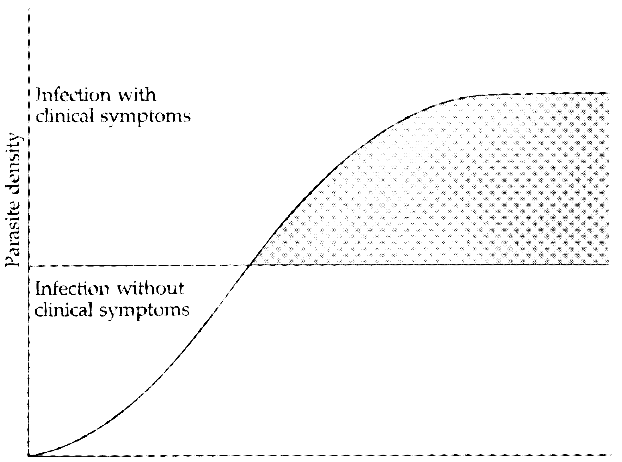

Correlation between diseases with clinical symptoms and parasite density

modes of transmission
effects of parasites on hosts
mechanical effects, such as pressure from an enlarged cyst or obstruction of vessels by the parasite itself
invasion and destruction of host cells
immunological responses to the parasite or parasite products
competition for host nutrients
parasite species and correct use of scientific names (written and spoken)

