Invertebrate Zoology
The protozoans
Introduction
Protozoa are eukaryotic, unicellular organisms (generally microscopic in size) that live as single individuals or in simple colonies. Within the unicellular body of a protozoan are many organelles that are analogous to the organs and organ systems of animals. Thus, protozoa (particularly ciliates) exhibit a great deal of intracellular complexity. Most scientists believe that multicellular animals evolved from some group or groups of ancestral protozoa. Historically, there has been some disagreement among biologists over which group of protozoa may have been the real ancestors of the multicellular animals, but flagellates are often cited as the most probable ancestral group.
For many years, biologists considered the protozoa to be the simplest group of animals and traditionally included them as the most “primitive” phylum in the animal kingdom. As research with unicellular eukaroytes progressed, biologists began using a five-kingdom system mainly based on morphological similarities (Monera, Protista, Fungi, Plantae, and Animalia).* More recently, the traditional classification scheme with a single “Kingdom Protista” has been revised to more accurately describe the evolutionary history of the unicellular eukaryotes. Molecular evidence suggests that the differences among various groups are sufficiently important and that they should be divided into separate phyla, further complicating classification of the protozoa. In this class, we will use the terms protist and protozoa in an informal sense to refer to unicellular eukaryotes.
* Many taxonomists consider the five-kingdom system obsolete.
Some 70,000 species of protozoa have been described; including species widely distributed in many kinds of moist or wet habitats; in fresh, marine, and brackish waters; in sewage; in moist soil; in or on the bodies of many species of animals; and in or on some plants.
Evolution of Multicellularity
Several related flagellates are often studied as models to illustrate one popular hypothesis for the evolution of multicellular organisms. Most scientists believe that multicellular organisms arose from some unicellular form. This major evolutionary step took place more than 600 million years ago in the Precambrian Era. No well-preserved fossils have been found that document this transition from one to many cells, so biologists have searched among living plants and animals to seek models that might help their understanding of early evolution.
Laboratory Procedures
The Flagellated Protozoans
Euglena is a common green flagellate often found in the greenish surface scum of standing or slowly moving water. Euglena is an enigmatic organism with a curious mixture of plant and animal characteristics. Euglena is smaller than most of the other protozoans you will observe (e.g., Amoeba and Paramecium) and, therefore, the details of its internal structure are more difficult to observe.
Active swimming movements result from the beating of the long flagellum, which pushes the organism through the water. A second, shorter flagellum is present within the flagellar pocket, but does not aid in the swimming movements. At certain times Euglena also exhibits another type of worm-like locomotion during which waves of contraction pass along the body in a characteristic fashion. This type of locomotion is peculiar to Euglena and related organisms and is appropriately termed euglenoid movement. It appears to result in part from the elasticity of the thick outer covering of the body, the pellicle.
- Prepare a wet mount of Euglena for examination: Place a drop of Euglena culture on a clean microscope slide. You may or may not want to add a drop of protoslo. Add a coverslip.
- Identify and sketch the following structures under high power on your compound microscope. (It may be difficult to observe these structures on live specimens so be sure to examine the preserved Euglena.)
- pellicle, the thick outer covering of the body  - chloroplasts with green chlorophyll  c. nucleus  d. the long anterior flagellum | 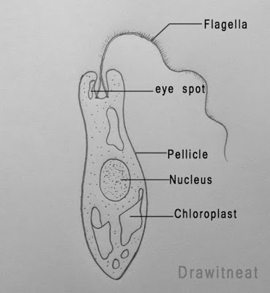

As suggested by the presence of chloroplasts, the nutrition of Euglena is normally autotrophic; organic molecules (sugars) are synthesized from inorganic nutrients absorbed from the medium. Sunlight provides the energy necessary for this process. Biochemical tests have shown the paramylum granules to be a form of starch similar to that found in plants. Thus, both the presence of the chloroplasts and the storage of a plantlike form of starch indicate a close relationship of Euglena and its relatives to the plant kingdom.
Dinoflagellates
Other important flagellated protozoans include the dinoflagellates, and the symbiotic flagellates that inhabit the digestive tracts of termites and the wood roaches. Some dinoflagellates (zooxanthellae) are mutualistic in the tissues of coral. Dinoflagellates are found in both fresh and marine waters; many species form a characteristic outer covering called a test that is made of cellulose. Certain freshwater dinoflagellates may cause an unpleasant odor or taste in human water supplies. Gonyczulax and Gymnodinium are two marine dinoflagellates often associated with the red tides of coastal waters of North America, Europe, and Africa that sometimes result in massive fish kills.
1. Make a wet mount of dinoflagellates.
2. Sketch.
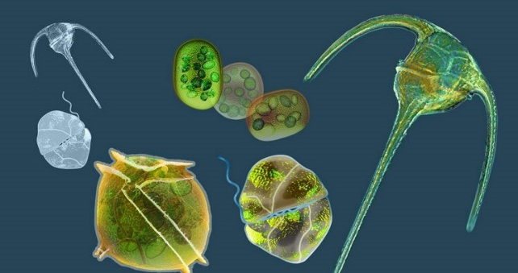

Trypanosomes are unicellular, parasitic flagellates characterized by a single, large mitochondrion (known as a kinetoplast). Trypanosoma brucei causes African sleeping sickness, a human disease transmitted by the bite of the tsetse fly. One reason that this disease is still widespread today in parts of Africa is that the surface coat proteins of these organisms changes rapidly (you can think of it as a parade of different antigens), preventing immunity from developing in hosts.
- Observe a prepared slide of Trypanosoma brucei
- Sketch

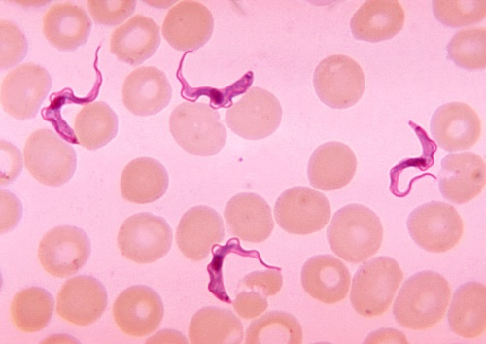

The Amoeboid Protozoans
Amoeba proteus is a representative amoeba that illustrates pseudopodia—cytoplasmic extension used for feeding and locomotion. These naked amoebas (without a shell) live on decaying vegetation at the bottom of freshwater lakes and ponds.
- Make a wet mount of Amoeba
- Start with low power on your compound microscope to observe the specimen
- Identify and sketch the following structures under on your compound microscope. (Specimens do not always arrive alive, so be sure to examine the preserved Amoeba)
- Sketch
a. Pseudopods (or pseudopodia)  b. Ectoplasm: viscous, clear outer layer of the cytoplasm in amoeboid cells (gel)  c. Endoplasm: fluid, granular inner layer of the cytoplasm in amoeboid cells (sol) | 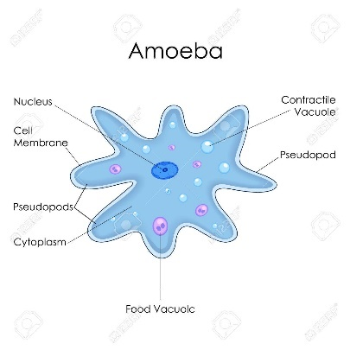
Radiolarians form skeletons or tests of silicon (glass) and exhibit many beautiful shapes. The radiolarians are among the oldest known protozoa, and their tests are abundant in marine sediments in many parts of the world.
1. Observe a prepared slide of radiolarians.
2. Sketch.
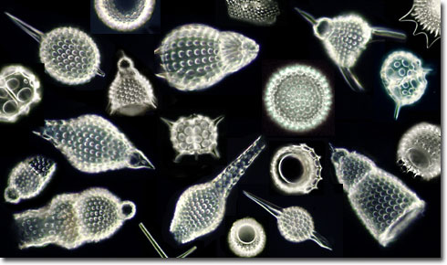

Foraminiforans (forams) are an ancient and important group, which form tests of calcium carbonate or other materials. The shells of foraminiferans accumulate on the sea bottom and contribute to the formation of chalk and limestone. England’s White Cliffs of Dover are made up largely of foram tests, as is much of the Bedford limestone found in Indiana and Illinois, and some of the limestone that was used to build the Egyptian pyramids. The distribution of certain species of forams is also very important to petroleum geologists as an indication of ancient environmental conditions that may have been favorable for the formation of petroleum and thus as important clues to the location of petroleum reserves
- Observe a prepared slide of foraminiforans.
- Sketch
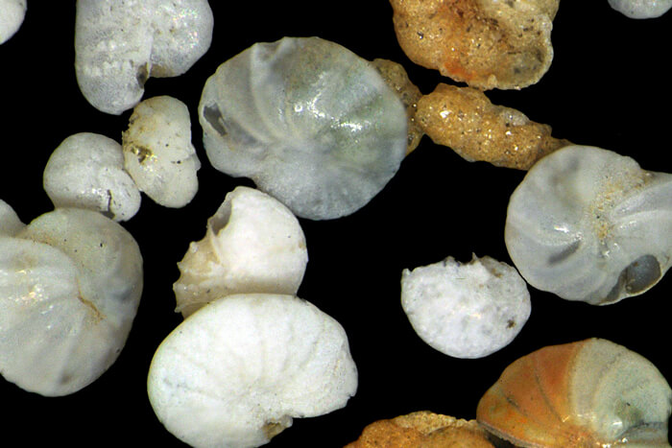

Phylum Apicomplexa
The malaria parasite: Plasmodium
More than 50 species of Plasmodium have been described. All are intracellular parasites of vertebrates, including amphibians, reptiles, birds, and mammals. Four species cause human malaria, (P. ovale, P. vivax, P. malariae, and P. falciparum). The life cycles of these species are all similar.
Malaria, one of the most serious and debilitation of human diseases, has had an important role in history from the fall of the Roman Empire to the war in Vietnam. Although modern medicine has made some progress in eliminating malaria, the disease is yet to be conquered. It is most prevalent in tropical and semitropical areas and costs millions of lives and trillions of dollars annually.
- Observe a prepared slide of Plasmodium. The developing Plasmodium organisms inside the erythrocytes exhibit a characteristic morphology, as seen in giemsa-stained microscope preparations, and are recognized by their red nucleus and blue ring-shaped cytoplasm.
- Sketch
- Identify the ring stage of the parasite  - Identify uninfected RBCs  - Identify WBCs (if present) | 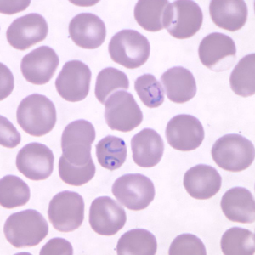

Phylum Ciliophora
Paramecium is a large, common, ciliated protozoan often found in water containing bacteria and decaying organic matter. There are several species of Paramecium that differ in various details of structure and that range in length from about 120—300 μm. We will look at Paramecium caudatum, a species frequently used for laboratory study and experimentation.
- Prepare a wet mount: Obtain a drop of Paramecium culture in a clean pipette and place it on a clean microscope slide. Add a coverslip.
- Observe your preparation under low power with your compound microscope. Note the incredible mobility of Paramecium. Note the form, color, and behavior of the organisms in your preparation.
- Select a large, immobile, or slowly moving specimen (or use protoslo), and with the aid of the accompanying figure identify the following structures. (It may be difficult to observe these structures on live specimens so be sure to examine the preserved Paramecium.)
- Sketch and identify the following structures:
- Pellicle: the thick outer covering of the body through which the cilia project. The pellicle has a complex structure, but its details are difficult to observe without special techniques.  - Cilia: the numerous protoplasmic extensions that cover the surface of the Paramecium and that function in locomotion and in food gathering.  - Macronucleus: the large nucleus located near the center of the cell. Since it is transparent in a living animal, the structure of the macronucleus is best studied in a stained preparation. Experiments have demonstrated that the macronucleus controls most metabolic functions of the cell.  - Micronucleus: is involved primarily in the reproductive and hereditary functions of the organism. This presence of two distinct types of nuclei is called nuclear dimorphism and is a condition found only in the Phylum Ciliophora. Paramecium caudatum has only a single micronucleus, but some other species of Paramecium have two or more micronuclei. As with the macronucleus, the structure of the micronucleus is best studied in a prepared microscope slide.  - Cytostome (cell mouth): a permanent opening near the posterior end of the oral groove through which food is passed. | 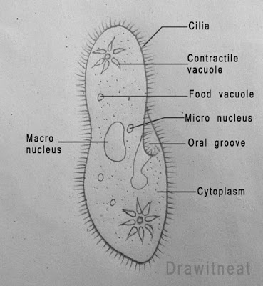
 | f. Contractile vacuoles: two clear, slowly pulsating vesicles located near each end of the organism. Each contractile vacuole is surrounded by several radiating canals (not often seen in ordinary preparations) which collect water from the surrounding cytoplasm. The function of the contractile vacuoles in Paramecium, is the collection and discharge of excess water from the cell. Freshwater protozoa often have contractile vacuoles; marine protozoa generally lack them. How would you explain this difference?

*Material for this lab was taken from: Lytle, C.F., and Woodsedalek, J.E. General Zoology WM. C. Brown Publishers
More live protozoans (optional)
Flagellates
1 Chlamydomonas
1 Volvox*
Amoeba
2 Actinosphaerium*
1 Arcella
1 Difflugia
Ciliates
1 Blepharisma
1 Didinium
1 Spirostomium
1 Stentor
1 Vorticella
(*Volvox and Actinosphaerium are very fragile – try not using a cover slip)

Review Questions
- In the Paramecium what is the function of the contractile vacuoles?

- In a hypothetical situation why would marine Paramecium species lack contractile vacuoles?

- What is the difference between cilia and flagella?

- Give 2 examples of parasitic protists and the disease they each cause? How do these organisms obtain nutrients?

- Why would excess water accumulate in amoebas?

- What does the malaria parasite (Plasmodium) do to red blood cells (erythrocytes)?

- What benefit could we get from finding a large deposit of foraminiferan tests?

- Why is conjugation considered a form of sexual reproduction? What evolutionary benefit does conjugation provide that binary fission does not?

